Professional Building , Weymouth, Massachusetts

Ambient Engineering assumed responsibility for permitting, design, and construction of an 8,100 SF professional building in Weymouth, Massachusetts. Services included design, permitting, sub-consultant coordination, and construction phase services.

Civil design was performed by an Ambient project manager while at Rizzo Associates and included site grading, drainage, utility layout, and parking lot layout. Site constraints included adjacent bordering vegetated wetlands, high groundwater, significant grade changes, and portions of the Site being in the floodplain. Design solutions included a rain storage system that collects roof runoff and reuses it for irrigation; a 24,000 gallon underground concrete tank is used for stormwater control as well as providing enough storage to irrigate the Site for 15 days without rain. By not tying into the municipal water system for irrigation, the system saved the owners a portion of the connection mitigation fee normally charged.

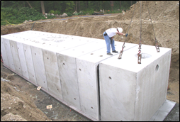

Design permits for the project included a Special Permit from the Weymouth Board of Zoning Appeals, Notice of Intent from the Weymouth Conservation Commission, and Application to Access State Highway from the Massachusetts Highway Department. Abutters appealed the Conservation Commission’s decision to the state level, but the project was approved with a Superseding Order of Conditions from the Massachusetts Department of Environmental Protection.

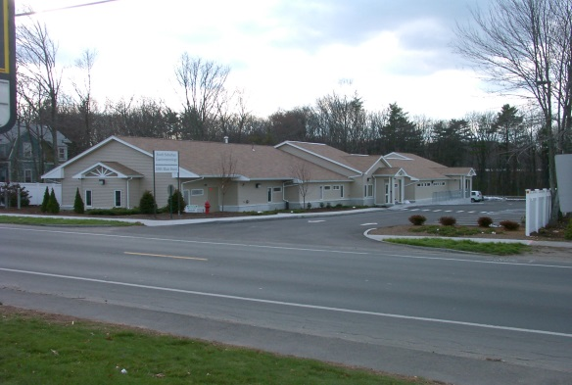

During construction Ambient provided technical project specifications, answered requests for information, provided shop drawings, attended project meetings, and made regular site visits. The project required the management of numerous sub-consultants, including surveyors, risk assessors, geotechnical engineers, and wetland scientists

