Wetlands Delineation and Permitting Services
Various Sites, Massachusetts

Ambient provides comprehensive environmental services to industrial, commercial, and residential clients related to land use and development activities subject to the Massachusetts Wetland Protection Act and more stringent municipal bylaws.

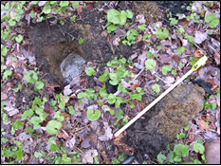

Ambient has expertise with the assessment of jurisdictional wetlands and the determination of associated regulatory compliance issues. Our staff can evaluate wetland conditions on a subject property with a reconnaissance site visit or a formal delineation of wetland boundaries. Field activities are supported by office review of information immediately available from third party sources such as: online state and municipal GIS data including assessor’s parcel lines, zoning, streams, and wetlands; aerial photography and remote images; USGS topographic maps; available USDA Soil Survey Report soils maps; and FEMA flood plain data.

After establishing the presence and extent of wetland resources, Ambient can perform a determination of the

Applicability of federal, state, and local regulations to identify regulatory obligations and permitting requirements for development of a site. Ambient provides related services including: Site plan preparation; Municipal Permitting assistance with appearances before the local Conservation Commission, Planning Board, Board of Health, and Zoning Board of Appeals; and NPDES stormwater discharge permitting with development of project-specific

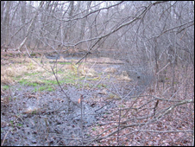

Stormwater Management Plans. To expedite the permitting process, Ambient can perform a survey of existing conditions at the Site and Project vicinity to develop plans showing property lines, topography, and public and private utilities servicing the property.

Ambient works closely with clients when exploring a property for purchase or making changes to properties they already own. With our civil engineering capabilities, we can assist our clients with layout and design of stormwater controls during the construction phase; post-construction site drainage; and sewer and water systems.

