Immediate Response Action
Wellesley, Massachusetts

Ambient was retained to provide LSP services for a release of approximately 150 gallons of fuel oil occurred from a heating oil above-ground storage tank (AST) in Spring 2005. The release was within a ground floor furnace room of a retail store located within a strip mall and adjacent to the ground floor of a restaurant.

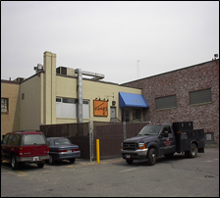

Under an Immediate Response Action (IRA) Plan, Ambient supervised emergency response actions, which included pumping of oil from the furnace room, along with application and off-Site management of absorbent materials.
Approximately 27 tons of petroleum hydrocarbon-impacted sandy soil was removed within 5 days of the release through the use of a vactor truck. The excavation area was backfilled with flowable fill. Soil excavation was limited along the wall of the furnace room that abutted the restaurant, due to structural issues. This issue required additional assessment activities within the restaurant, to evaluate for a Critical Exposure Pathway (CEP) condition.

Groundwater was not encountered during remedial activities.
Assessment activities included advancement of soil borings within both the retail and restaurant buildings.
In addition to implementation of ventilation measures throughout remedial activities, indoor air sampling was conducted by installing summa canisters during and after remedial measures, to assess potential impact to indoor air. Ambient also installed a soil gas vapor point and conducted Air Petroleum Hydrocarbon (APH) analysis.
Groundwater was sampled at a downgradient monitoring well for Volatile Petroleum Hydrocarbon (VPH) and Extractable Petroleum Hydrocarbon (EPH) analysis.
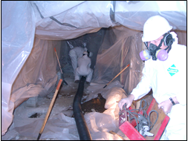
The challenge of this project was to conduct assessment, remedial and sampling activities within a timely period, so as to not interrupt retail activities. Due to the proximity of the release to the restaurant, Ambient worked closely with the local health department to assure that worker exposure to petroleum hydrocarbon compounds in indoor air was both assessed and mitigated. A Permanent Solution was achieved under a Class A-2 Response Action Outcome (RAO) Statement.

