Electrical Substation Expansion Weare, New Hampshire

Ambient Engineering is providing regulatory compliance and civil engineering services to Public Service of New Hampshire (PSNH) to construct an electrical substation at Norris Road in Weare, New Hampshire in the vicinity of an existing right-of-way for PSNH transmission lines.
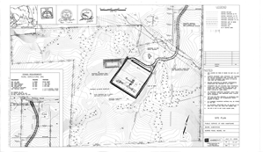
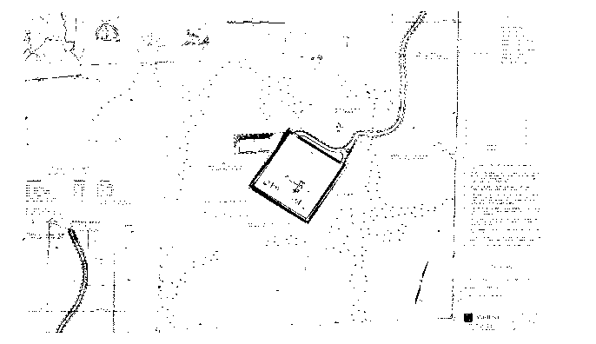
The substation will enhance electric service locally and regionally. PSNH’s decision to purchase this property for substation installation rested on Ambient’s ability to expedite the permitting process for all local and state permit applications.
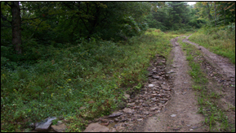

Ambient’s regulatory compliance services included all activities necessary to obtain the following permits:
- Special Exception from the Weare Zoning Board of Adjustment
- Site Plan Approval from the Weare Planning Board
- · Approval from the Weare Conservation Commission of a Minimum Impact
- Expedited Dredge and Fill Application
- Dredge and Fill Permit from NH Department of
- Environmental Services Site Specific Permit from NHDES
- Construction General Permit from the EPA
- Civil engineering services included the following:
- Property line and topographic survey
- Wetland delineation
- Substation site selection
- Geotechnical investigation
- Site plan development
- Grading and drainage design
- Soil erosion and sedimentation control program
- Stormwater management report and stormwater
- Pollution Prevention Plan

