Single Family Home Within a Flood Zone
Request for Superseding Order of Conditions
Waltham, Massachusetts
The site was a subdivided 15,000 square foot residential lot in Waltham, MA. Ambient Engineering was contracted to represent the developer and to oversee development of a single family residence on the property. The project had been denied at the local town Conservation Commission level and as being appealed. Residents in the area had concerns that development of this lot would increase the potential for flooding originating from a local stream. The FEMA Flood Insurance Map did not indicate the area to be in a Flood Zone, nor did the USGS Topographical Map show the perennial stream. Although, the FEMA flood zone maps didn't show the area within a flood zone, photo documentation supported the residents' complaints of flooding in the area.
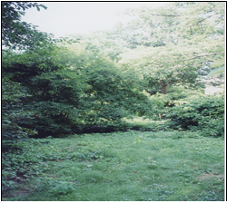

Based upon hydraulic calculations using the 100 year storm event, the area was determined to have a substantial flooding problem. Most of the flooding potential was attributed to historical under sizing of the storm drains.

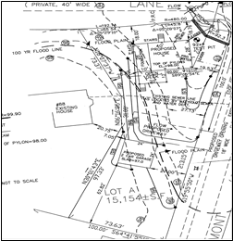

Since the project site was determined to be in a flood zone based on hydraulic calculations, regulations required a wildlife habitat study to be performed. This subdivided lot was once manicured lawn, therefore Ambient presented the case that only the portions of the site primarily composed of native vegetation had to be evaluated. All other areas on the site were determined to be extensively altered by human activity at a previous time, and therefore, any wildlife habitat functions significant to the Wetlands Protection Act have been eliminated.
The natural vegetated areas on the site were cumulatively less than 5,000 square feet, or 10% of the lot. Therefore, it was Ambient's conclusion that no wildlife study was required for this site, in accordance with 310 CMR 10.57 (4)(3) .
Ambient assisted the client with permitting support, reviewed the permitting material, and represented the client for the DEP Superseding Order of Conditions. Ambient was a liaison between DEP, the client, and the neighbors assuring that all parties had the necessary information required to permit the project.

