Village Square
Ashland, Massachusetts

Ambient Engineering (Ambient) is providing civil engineering and permitting services for the land development of 12.8 acres of commercial property on Pond Street (State Highway Route 126) in Ashland, Massachusetts. The site includes a wetland designated area at the rear of the property, an intermittent stream as determined by DEP, and a 100 year flood plain district.

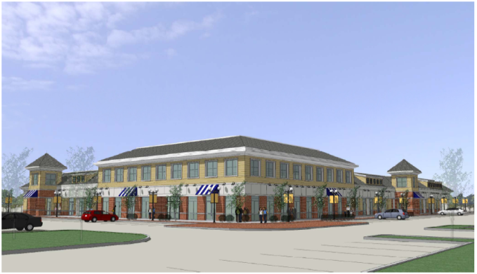

The proposed commercial development includes two retail/commercial structures and a drive-thru (Class II) restaurant along with associated parking and utilities. The structures will be connected to municipal water and sewer systems.

Ambient worked alongside an Architect to develop site plans for permitting and created designes appropriate for permitting based on the architectural and landscape.

This effort included:
- Topographic Survey, including wetlands delineation.
2. Site Layout, including building layout, parking layout, site distance, and setbacks.
3. Grading, Drainage, and Utilities Plan, showing site grading and drainage system as well as modified utility connections.
4. Stormwater design using Hydro CAD
5. Lighting and Landscaping Plan, showing proposed locations of site lighting, landscaping, and snow storage.
6. Erosion Control Plan, showing erosion control measures to be taken during construction.
7. Construction Details.

Ambient was responsible for securing approvals from the Conservation Commission, Planning Board, Board of Appeals, and Massachusetts Highway Direct Access Permit.

