Stormwater Education Materials
SuAsCo Watershed Community Council
Ambient Engineering has been a consultant to the SuAsCo Watershed Community Council and has provided a variety of services related to SuAsCo’s Stormwater Community Assistance Program (SWCAP). SuAsCo is a community-based alliance that promotes the sustainable economic and environmental well-being of the Sudbury-Assabet-Concord River watershed.

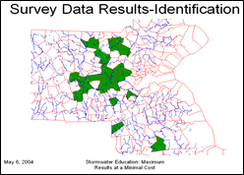
As part of a multi-discipline team including consultants, member communities, and state officials, Ambient helped SWCAP prepare guidance documents for communities to meet their NPDES Stormwater Phase II Minimum Control Measures. SWCAP has 23 member communities both in and out of the SuAsCo watershed using the programs tools to meet their requirements for both public education and outreach as well as public participation and involvement.
SWCAP has prepared materials for two of the five years of the program. The first year focused on raising awareness of community’s watersheds. Portable displays were prepared that highlighted current watershed issues and provided information on improving water quality.

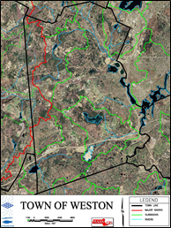

The second year program focused on education. SWCAP prepared materials to be used in fifth- or sixth-grade classrooms. The materials focused on watersheds and the relationship between stormwater and water quality. SWCAP provided maps to the towns showing municipal boundaries and watersheds overlain on color aerial photos.
Ambient led two specific project components of the SWCAP program. In the first year, it created a Microsoft Access database to compile the survey results. The database was linked to a Microsoft Excel spreadsheet and Microsoft Word document to create customized reports for each community. Ambient compiled results and presented them at SuAsCo’s annual River Visions conference.
In the second year, Ambient created a number of maps for each community to use in its education and outreach program. The first was a watershed map of the state. The second was a color GIS map for each community.

