Stoughton Memorial Village, Stoughton, Massachusetts

Ambient Engineering was responsible for a study on the feasibility of expanding housing on a site owned by the Stoughton Housing Authority. The study included a review of existing site conditions, a review of current records and applicable regulatory guidelines, an architectural review, an accessibility review, and description of development alternatives.

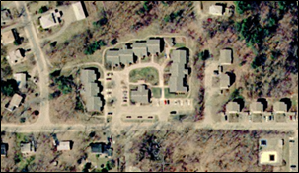

The review of existing site conditions included a discussion of property line information, topography, soils, wetlands, vernal pools, rare species habitats, zoning districts, and site characteristics.

The record review consisted of reviewing existing surveys and plans and access to utilities such as sewer, water, telephone, cable/internet, electricity, and gas. Existing stormwater management, zoning requirements, and environmental conditions were documented.

The accessibility review considered accessibility requirements that would have to be met, primarily from federal (ADA Guidelines) and state (Massachusetts Architectural Access Board) guidelines.

The feasibility study recommended two development scenarios for the Authority to consider pursuing. Advantages and disadvantages were presented and discussed.
The development regulatory analysis included a zoning review and discussion of permits required for different development scenarios. It considered the advantages and disadvantages of seeking variances from the zoning bylaws.

The architectural review included schematic architectural sketches of proposed building modules. These sketches provided a building layout as well as a site footprint around which a preliminary site layout was designed..

