MCP Phase I Investigations
Maynard, Massachusetts

Ambient was contracted by a private commercial property owner to evaluate the results of a Down gradient Property Status (DPS) Opinion for an abutting property. The site has operated as an automotive auto body and service facility for 20 years and also as a former gas station.

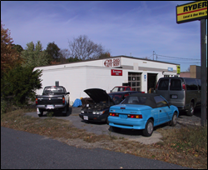

Ambient conducted subsurface investigations at the site in 2002, which included the advancement of soil borings and installation of groundwater monitoring wells. Ambient also supervised the removal of two (6,000-gallon) and one (10,000-gallon) gasoline underground storage tanks (USTs).

Ambient prepared a Phase I Initial Site Assessment and Tier Classification Report and a Phase II Scope of Work.

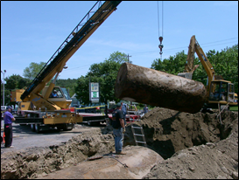

Additional soil and groundwater subsurface activities were proposed for. These investigations include off-Site investigations, to assess the extent of petroleum hydrocarbon impact.

Based upon the results of Phase II investigations, Ambient will determine if additional remediation is required to achieve a Permanent Solution under the Massachusetts Contingency Plan (MCP).

