New Bedford, Massachusetts
Housing Authority

Ambient Engineering was responsible for the reconfiguration and repaving of an existing parking lot and the reconstruction of walkways for the Apollo Drive and Navajo Court developments owned by the New Bedford Housing Authority. The project included design, permitting, coordination of sub-consultants, and construction phase services.
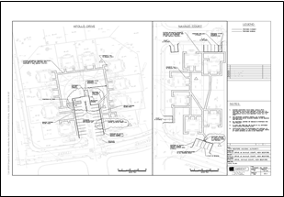
Civil design was performed in order to increase the number of parking spaces for tenants and visitors within tight site constraints. Design was also conducted to relocate existing dumpsters and to repair stairs that lead from the parking lot to the development. Portions of the existing site were re-graded to improve drainage around housing units. Ambient reviewed existing utilities, subdivision, sewer, and drainage plans and compiled them into an as-built plan.

Permitting was limited to working with the Town to comply with requirements for utility work. The project required the management of sub-consultants, including surveyors and accessibility specialists.
Ambient managed the bidding for the project in accordance with Department of Housing and Community Development guidelines and Massachusetts General Laws Chapter 30 Section 39M.
During construction Ambient provided technical project specifications, answered requests for information, provided shop drawings, attended project meetings, and made both scheduled site inspections and special inspections for critical construction events.

