MCP Remediations
Everett, Massachusetts

Ambient provided LSP and MCP services for the Coleman Manufacturing Company, located at 48 Waters Avenue in Everett, Massachusetts.

A Notice of Responsibility was issued by the Massachusetts Department of Environmental Protection (DEP).. The NOR indicates that an arsenic release to soil at the southwesterly abutting property (railroad right-of-way) may be associated with former operations at the Coleman facility and/or the Fort Hill Bronze Manufacturing Company, formerly located on a portion of the Coleman property. The railroad right-of-way is owned by the Massachusetts Bay Transportation Authority (MBTA).

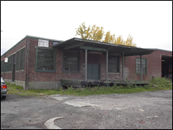

Ambient prepared a Phase I Initial Site Assessment and Tier Re-Classification Report . The Phase I report included a review of historical development within the immediate area that may be contributed to arsenic-impact.

An Immediate Response Action (IRA) Plan and Imminent Hazard Evaluation were prepared by Ambient. The IRA Plan and IRA Status Reports included subsurface investigations at up to four nearby residential properties. The IRA Plan and Phase II Comprehensive Site Assessment were conducted concurrently under two separate Release Tracking Numbers.

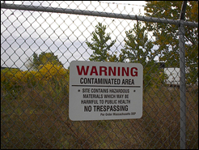

An additional (third) RTN was assigned associated with elevated concentrations of petroleum hydrocarbon compounds in soil and arsenic in groundwater at the property.

The residential Site was cleaned up by removing shallow soil and replacing it with loam. Landscaping was also provided. The railroad right of way was cleaned up by removing soil and replacing it with gravel. The Site was capped and converted to a paved bike trail.

As of 2013, two of the three arsenic impacted Sites have been closed with Permanent Response Action Outcomes (RAO’s).

