ASTM Phase I Environmental Site Assessment
Battle Green Inn Lexington, MA

Ambient Engineering was retained by the owners of the Battle Green Inn to perform a Phase I Environmental Site Assessment (Phase I) at a parcel of land in downtown Lexington, Massachusetts (the Site) that is comprised of a two-story motel building with an underground parking garage. Ambient followed American Society for Testing & Materials (ASTM) protocols which are recognized by most financial institutions as being appropriate for real estate assessments. The scope of work for this Phase I also included a specific investigation into the current status of the Site as it related to a claim of Downgradient Property Status naming the previous owners of the Battle Green Inn as responsible for contamination discovered at the adjacent commercial property.

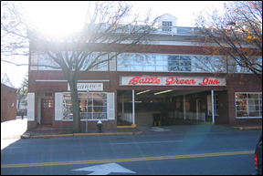

Available documents indicated that No. 2 fuel oil was discovered in a sump in the basement of the adjacent commercial property located across an alley from the

Site building. Due to the discovery of fuel oil in the basement sump of the adjacent property, and the presence at that time of a 5,000-gallon aboveground storage tank

(AST) in a vault at the Battle Green Inn located close to the adjacent building, the consultant for the adjacent property submitted a Downgradient Property Status (DPS) opinion to DEP naming the Battle Green Inn as the source of contamination.

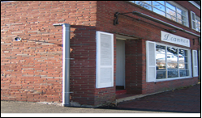

While conducting this Phase I, a search of DEP records online indicated that the status of the Site was that the Battle Green Inn was still considered to be the source of contamination at the adjacent property. Ambient determined that based on the available information that assessment activities conducted to date at the Site were sufficient to render an opinion that the AST at the Battle Green Inn was not the source of contamination at the adjacent property and therefore the Battle Green Inn did not likely have any liability under the Massachusetts Contingency Plan (310 CMR 40.0000).

