ASTM Phase I Environmental Site Assessment
Lawrence, Massachusetts

Ambient Engineering, Inc. was retained by the RPP Corporation to conduct a Phase I Environmental Site Assessment (ESA) at its rubber manufacturing facility in Lawrence, Massachusetts. The facility is located within an industrial park.

As part of Phase I activities, Ambient conducted an inspection of its facility to gain an understanding of its operations, include use, storage and disposal of oil and/or hazardous materials (OHM).

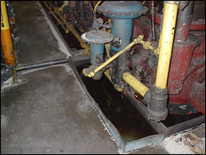

Ambient identified multiple environmental concerns and Recognized Environmental Conditions (RECs) associated with operations. Findings included areas of potential surficial releases of OHM, along with improper closure of a former underground storage tank (UST) and issues regarding housekeeping of OHM.

Based on the RECs, Ambient recommended additional Phase II subsurface investigations.

