Governor’s Crossing, Hopkinton, Massachusetts

Ambient Engineering (Ambient) provided civil engineering and permitting services for the 26 unit senior housing residential development on Wilson Street in Hopkinton, Massachusetts. The 13.1 acre site includes wetland designated areas within most of the property.

The proposed senior housing residential development includes access roadways, 26 full-basement two-bedroom units with associated parking and utilities. The units will be connected to municipal water and a common Presby on-site sewer septic system designed by Ambient.

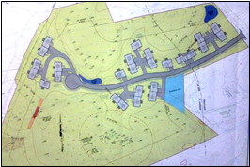

A temporary 175’ long by 15’ wide wetlands crossing is required at the south side of the property to allow for the installation of underground sanitary sewer pipes. The wetlands crossing area will be restored to its original condition once construction activities are complete.
Ambient collaborated with the Architect to develop site plans for permitting.

the drainage improvements included the installation of catch basins with hoods and sumps, a subsurface piping network, infiltration basins, oil/grease separators, and detention ponds.
Ambient provided the following services:

· Developed site plans appropriate for permitting based on the architectural design. This effort included:
1. Wetlands delineation.
2. Site Layout, including building layout, site distance, and setbacks.
3. Grading, Drainage, and Utilities Plan, showing site grading and drainage system as well as modified utility connections.
4. Stormwater design using HydroCAD 7.10.
5. Erosion Control Plan, showing erosion control measures to be taken during construction.
6. Construction Details.

Ambient was responsible for securing approvals from the Conservation Commission, Planning Board, Board of Appeals, and Board of Health.

