Former Boston and Maine Railroad Property
Gardner, Massachusetts
Phase I Site Assessment

Ambient Engineering was selected by a regional transportation authority to conduct a due diligence audit of a parcel of land in an industrial area of Gardner, Massachusetts. The property was located at the intersection of two historically busy railroad lines in the former “Chair City”, one of the foremost furniture manufacturing towns in 19th century New England. A building and train platforms, formerly located on the property, were used to weigh and temporarily store goods being shipped to and from this manufacturing center.

Ambient conducted a Phase I Environmental Site Assessment, in accordance with ASTM-E1527 00: Standard Practice for Environmental Site Assessments: Phase I Environmental Site Assessment Process. The Phase I was performed for the transportation authority, who was considering purchasing the property for use as an intermodal transportation center. The Phase I Environmental Site Assessment included an evaluation of site history, interviews with persons knowledgeable about the property and its history, a review of historical photographs and maps, a review of the past property owners and operators using land deeds and city directories; a site of hazardous substances management or contamination; an analysis of reconnaissance to identify visible signs

Regulatory Compliance; and a review of standard environmental records to determine if the property could be adversely impacted by a release of oil and/or hazardous materials from other nearby properties.
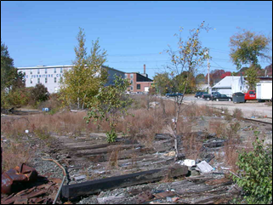

Ambient unearthed a history of surficial dumping, asbestos contamination and violations that resulted from a fire at the former freight house, and releases of petroleum products from several nearby properties that may have impacted the subject parcel. The former property owner and demolition contractor had been fined and held accountable for a release of asbestos to soil on the property. The asbestos was from boiler insulation, pipe wrap, and paper insulation, and was released during demolition of the damaged structure. To determine the impact of the nearby releases of gasoline and fuel oil, Ambient prepared a scope of work for a subsurface investigation that included the advancement of several soil borings and installation of groundwater monitoring wells.

