Electrical Substation Expansion
Fitzwilliam, New Hampshire

Ambient Engineering provided regulatory compliance and civil engineering services to Public Service of New Hampshire (PSNH) to construct an electrical substation in Fitzwilliam, New Hampshire. As part of a regional project referred to as the “Monadnock Region Upgrades”, PSNH planned to construct a new substation to tie its transmission line with two transmission lines owned by National Grid, USA.

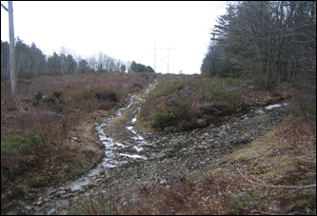

Ambient’s regulatory compliance services include all activities necessary to obtain the following permits:
· Site Plan Approval from the Fitzwilliam Planning Board
· Dredge and Fill Permit from NH Department of Environmental Services (NHDES)
· Site Specific Permit from NHDES
· Construction General Permit from the EPA

Civil engineering services include the following:
· Property line and topographic survey
· Wetland delineation
· Geotechnical investigation
· Site plan development
· Grading and drainage design
· Soil erosion and sedimentation control program
· Stormwater management report and stormwater pollution prevention plan
· Construction plan preparation
Ambient prepared permits, reports, and design documents, and present before multiple boards for permit approvals. Ambient worked closely with PSNH to anticipate schedule constraints and expedite project permitting.

