Electrical Substation Expansion
Concord, New Hampshire

Ambient Engineering provided regulatory compliance and civil engineering services to Public Service of New Hampshire (PSNH) to expand an electrical substation in Concord, New Hampshire. PSNH sought to expand the substation to allow for improved access to existing and proposed equipment
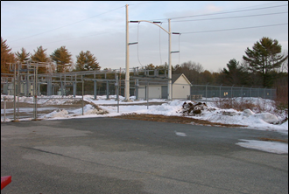

Ambient’s regulatory compliance services included all activities necessary to obtain necessary permits including:
· Site Plan Approval and Conditional Use Permit from the Concord Planning Board
· Through coordination with PSNH and proper positioning of power line poles, wetland impacts were avoided. The total area of land disturbance also was kept to a minimum. Thus, state permits for wetland and terrain alteration were unnecessary.

Civil engineering services included the following:

· Property line and topographic survey
· Wetland delineation and survey
· Geotechnical investigation
· Site plan development
· Grading and drainage design
· Soil erosion and sedimentation control program
· Stormwater management report
· Construction plan preparation

Ambient prepared permit applications, reports, and design documents, and presented before the Concord Planning Board for permit approvals. Ambient communicated regularly with city officials to ensure that permits were received promptly and that all permitting issues were addressed.

