Brownfield Redevelopment
Lowell, Massachusetts

Ambient Engineering was retained by a local property owner to conduct an environmental assessment of a former warehouse/light manufacturing facility located on the Concord River in Lowell, Massachusetts. The environmental assessment was conducted to identify Recognized Environmental Conditions as defined in the ASTM Standard Practice for Environmental Site Assessments: Phase I Environmental Site Assessment Process, Designation E 1527-00 (the ASTM Standard).

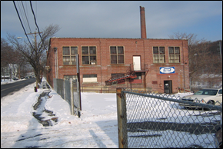

The 15,000 square foot property was occupied by an abandoned two-story brick warehouse and light manufacturing building, circa 1920, and associated asphalt-paved parking lot owned by Canalside Realty Trust.

Ambient conducted a visual inspection of surficial conditions in interior and exterior portions of the property, interviewed the

property owner and local municipal officials, reviewed readily-available local records, reviewed previous environmental reports. Based on the results of this investigation, Ambient identified several Recognized Environmental Concerns including a floor drain, historic records of a 1,000-gallon gasoline underground storage tank (UST), an a hydraulically powered, truck lift ramp, several unlabeled 5-gallon plastic containers full of used compressor oil, suspect asbestos containing building materials (ACBM), and fluorescent lamps and ballasts. Ambient worked closely with the property owner to determine that discharge point of the floor drain was the Concord River and not on-site, and to remove the used compressor oil and contaminated media located within the truck lift.

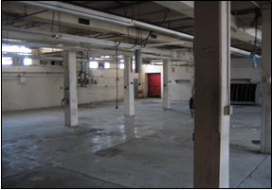

As a result of these response actions, Canalside Realty Trust was able to obtain financing to develop the property as first-class residential condominiums, with a roof-top garden overlooking the Concord River. State of the art stormwater management techniques were designed for the property to maximize the value of this redevelopment site.

